**Worry Worm**

These cute worry worms are meant to **put a smile** on whoever finds them and **comfort** them in times of sorrow or stress.

The idea of these worry worms is to go out of one's way to **make another person smile**. It builds a **sense of community in kind acts** and attempts to **make the world a bit lighter and brighter**!

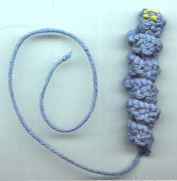

**Knitting pattern**

**Materials**

Scrap of dk – worsted weight cotton, or other yarn  
Needles to suit. You will need to knit quite tightly to get the knitting to curl so choose a size that will create a firm fabric.  
1 pair tiny googly eyes or puffy fabric paint

**Pattern**

Cast on 80 – 100 sts (sample uses 80sts and worsted weight yarn)

1st row: K2tog, repeat to end

2nd row: Cast off tightly, working k2tog across the row.

Break yarn leaving a long tail and fasten off. (This is the part of the bookmark that holds the place in our book).

Darn in end at cast on edge. Paint eyes and mouth using puffy fabric paint, or glue on googly eyes.

**Poem**

**I’m a little worry worm,**

**Keep me near and squeeze me tight,**

**Tell me your worries and I will make everything Alright!**

**Made with love from Sheffield MU**

**www.sheffieldmu.co.uk**