**Crochet pattern- Wiggle Worm**

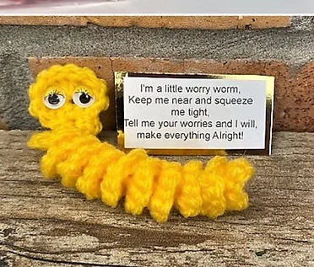

**-MATERIALS-**

· DK yarn in chosen colours

· 3.5mm crochet hooks

· Embroidery needle and scissors

· Googly eyes and glue

**-ABBREVIATIONS-**

· Magic Loop (I chain two and crochet into first loop to create ring)

· CH – Chain

· ST – Stitch

· SL ST – Slip stitch

· SK ST – Skip stitch

· SC – Single crochet

· HDC – Half double crochet

· DC – Double crochet

**Worm – make with chosen colour.**

1. CH30, 4SC into the 2nd CH from hook and the next 27 CH’s, 10DC all into the last CH, SL ST into same ST to join.

Join and fasten off.

**I’m a little worry worm,**

**Keep me near and squeeze me tight,**

**Tell me your worries and I will make everything Alright!**

**Made with love from Sheffield MU**

**www.sheffieldmu.co.uk**

Glue on 3-4mm googly eyes. Or stitch eyes