Please pray for the leaders of the Mothers’ Union.

Week 1.
Diocesan President Gill Fellows
Two Hon Vice Presidents Sheffield Norma Priest
DoncasterTo be appointed
Elected Vice Presidents JoAnne Van Levesley, Liz Paver, Tanis Cockerham
Diocesan Secretary Steve Bisby
Diocesan Treasurer Phill Jackson
Diocesan Chaplain Rev Hilda Isaacson/ Father Richard Parker

Week 2
Action and Outreach Co-ord Pauline Reynolds
Faith and Policy Co-ord Mary Williams
Finance Co-ord Gill Fellows
Fundraising & Communications Susan Sayles
Membership Development officer JoAnne Van Levesley
Deanery Leader Your Own
Diocesan Members Elizabeth Dean
Gift Aid Rep Phil Jackson

Week 3
A.F.I.A Rep Angela Parker
MU Enterprises Margaret Culloden
I.M.P.C. Rep Leslie Harpham
Prison play area Issy Mears
Newsline Editorial Team Gill Fellows, Moira Leach,
Pat Simpson. Elizabeth Dean Sarah Rogerson
Webmaster Elizabeth Dean
Data Co-ordinator Elizabeth Dean

Week 4
Our link Dioceses of; Central Zimbabwe Zimbabwe, Lango Uganda, Kebbi Nigeria, Tamale Ghana, Guadalcanal Solomon Islands
Diocese of Bondo
York Provincial President June Houghton
Zonal Trustee Catherine Hilton
Unit Coordinators and Staff at Mary Sumner House.
WW Link Correspondent Barbara Green
Radio Broadcasters in Sheffield, Doncaster and Rotherham.

Week 5
Your own Branch and Deanery.
Your own Vicar and Ministry Team.

Every week
World Wide President Sheran Harper
Chief Executive Beverley Jullien
Central Chaplain Rev Emma Ineson

As we enter prayer now, we pause to be still; to breathe slowly;
to re-centre our scattered senses upon the presence of God.
.
Creator God, you made the goodness of the land, the riches of the sea and the rhythm of the seasons; as we thank you for your gracious providing may we cherish and respect this planet and its peoples.
Living God, you call us to be good stewards of this earthly home: strengthen us to care for your creation; forgive us when, through our greed and indifference, we abuse its beauty and damage its potential. Empower us, through your Spirit to so nurture and love the world, that all creation sings to your glory.
God of creation and Lord of life, you entrusted us to care for our environment, but in many parts of the world we have failed. Help us to realise how fragile and unstable our surroundings are, because we are not looking after creation. Help us to understand how the most insignificant little flowers, and the tiniest insects, each creature and each individual are all part of a wondrous whole, through Jesus Christ our Lord.
Walk with us in our journey of hope

Disturb us, O Lord
when we are too well-pleased with ourselves
when our dreams have come true because we dreamed too little,
because we sailed too close to the shore.
Disturb us, O Lord
when with the abundance of things we possess,
we have lost our thirst for the water of life
when, having fallen in love with time,
we have ceased to dream of eternity
and in our efforts to build a new earth,
we have allowed our vision of Heaven to grow dim.
Stir us, O Lord
to dare more boldly, to venture into wider seas
where storms show Thy mastery,
where losing sight of land, we shall find the stars.
In the name of Him who pushed back the horizons of our hopes
and invited the brave to follow. Amen

Mary Sumner’s Personal Prayer
All this day, O Lord, let me touch as many lives as possible for thee; and every life I touch, do thou by thy spirit quicken, whether through the word I speak, the prayer I breathe, or the life I live. Amen

Closing Prayer
Father, help us to live this day to the full,
Being true to You in every way.

Jesus, help us to give ourselves away to others,
being kind to everyone we meet.

Spirit, help us to love the lost,
proclaiming Christ in all we do and say Amen

All prayers are taken from Mothers’ Union resources

Do not conform to the pattern of this world, but be transformed by the renewing
of your mind. Then you will be able to test and approve what God’s will is –
his good, pleasing and perfect will.
Romans 12:2

Diocese of Sheffield

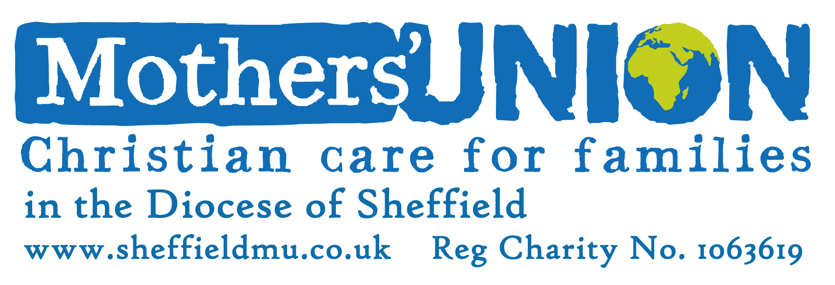

Prayer Leaflet 2024

5th Objective
To maintain a World Wide fellowship of Christians united in prayer, worship and service.



